Project Development Phase
Model Performance Test

DATE | 26-06-26
PROJECT NAME | SB Stocks is a user-friendly web app built for stock market enthusiasts.
MAXIMUM MARKS
Model Performance Testing:
Project team shall fill the following information in model performance testing template.
S.No. | Parameter | Screenshot / Values
 | Data Rendered | good
 | Data Preprocessing | Yah 100%
3. | Utilization of Data Filters | good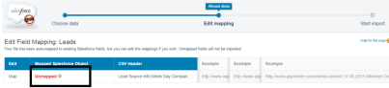
4. | DAX Queries Used | Some queries about code
5. | Dashboard design | No of Visualizations / Graphs -
6 | Report Design | No of Visualizations / Graphs -

